Power Point Notes Unit 2 Review Name :__________ Per.:____
Unit 2 Vocabulary:
- Plate Tectonics
- Erosion
- Mechanical Weathering
- Chemical Weathering
- Geology
- Weathering
- Core
- Crust
- Mantle
Guess the pictures activity:
1. ____________:
__________________________________________________________________________________________________________________________________________________________________.
2. ____________:
__________________________________________________________________________________________________________________________________________________________________.
3. ____________:
__________________________________________________________________________________________________________________________________________________________________.
4. ____________:
__________________________________________________________________________________________________________________________________________________________________.
5. ____________:
__________________________________________________________________________________________________________________________________________________________________.
6. ____________:
__________________________________________________________________________________________________________________________________________________________________.
7. ____________:
__________________________________________________________________________________________________________________________________________________________________.

8. ____________:
__________________________________________________________________________________________________________________________________________________________________.
9. ____________:
__________________________________________________________________________________________________________________________________________________________________.

The 3 MOST common types of erosion:
- ______________
- ______________
- ______________
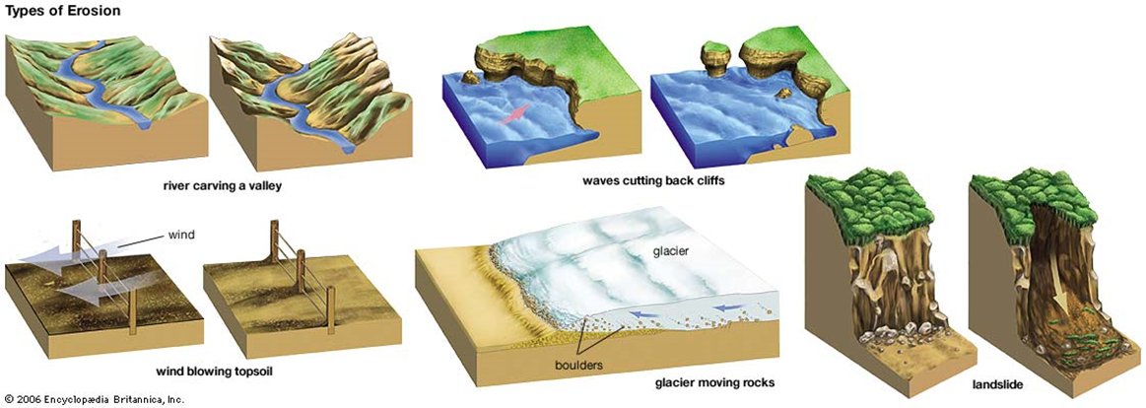
One of the best theories for plate tectonics is…
- ____________

One effect of chemical weathering is…
- ______________________________________________________________________________

