Day 2
Main Point Reading
SPANISH COLONIZATION
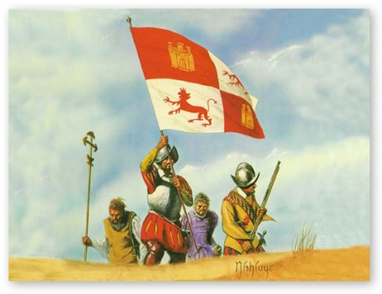
The arrival of Europeans in the New World in 1492 changed the Americas forever. Over the course of the next 350 years, Spain ruled a vast empire based on the labor and exploitation of the Indian population. Exploitation is the action of treating someone unfairly in order to benefit from their work. Conquistadors descended on America with hopes of bringing Catholicism to new lands while extracting great riches. Religion and self-interest combined to create a potent mixture that drew hundreds of thousands of Spaniards across the ocean with hopes of finding riches and winning souls for God. Along with the Spaniards came diseases to which the New World natives had no immunities.
What followed was one of the greatest tragedies in human history as smallpox, influenza, and other communicable diseases ravaged the native populations, killing millions. The Spanish never set out to destroy the people of the New World—after all, their goal was to use Indian labor for their own ends—and almost immediately a debate arose in Spain concerning the rights of Indians. This was the first time any European nation had consciously debated the rights and status of non-Christians. The traffic of Europeans to the Americas was not a one-way street. The so-called Columbian Exchange brought European goods and ideas to the New World—including the horse, which was not native to the Western Hemisphere—and returned new plants and animals to the Old World, including potatoes, corn, tomatoes and other crops. The world was forever changed by the new horizons opened by Spain's intrepid explorers, despite the misdeeds of Spanish rule in America.
Spanish conquistadors, who were primarily poor nobles from the impoverished west and south of Spain, were able to conquer the huge empires of the New World with the help of superior military technology, disease (which weakened Indian resistance), and military tactics including surprise attacks and powerful alliances with local tribes. Once an area had been conquered, it was partitioned into encomiendas, or grants of land. More importantly, the Indian people themselves were parceled out to the conquistadors, who were given title to the land and its people in return for a promise to teach the natives Christianity. This system was heavily abused, and Indians throughout the Americas were reduced to a condition of virtual slavery.

