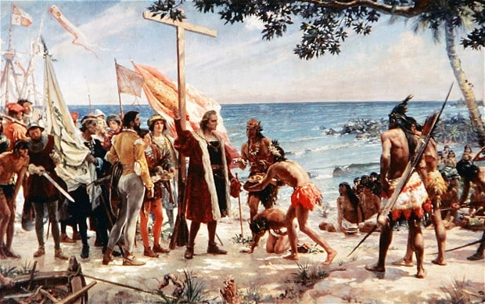
Day 1
Main Point Reading –
Earliest European Explorers

The first attempt by Europeans to colonize the New World occurred around A.D. 1000, when the Vikings sailed from the British Isles to Greenland, established a colony, and then moved on to Labrador, the Baffin Islands, and finally Newfoundland. There they established a colony named Vineland (meaning fertile region) and from that base sailed along the coast of North America, observing the flora, fauna, and native peoples. Inexplicably, after a few years Vineland was abandoned.
Although the Vikings never returned to America, their accomplishments became known to other Europeans. Europe, however, was made up of many small principalities whose concerns were mainly local. Europeans may have been intrigued by the stories of the feared Vikings’ discovery of a “new world,” but they lacked the resources or the will to follow their path of exploration. Trade continued to revolve around the Mediterranean Sea, as it had for hundreds of years.
Spain’s imperial ambitions were launched by Christopher Columbus. Born in Genoa, Italy, around 1451, Columbus learned the art of navigation on voyages in the Mediterranean and the Atlantic. At some point he probably read Cardinal Pierre d’Ailly’s early fifteenth-century work, Imago mundi, which argued that the East could be found by sailing west of the Azores for a few days. Columbus, hoping to make such a voyage, spent years seeking a sponsor and finally found one in Ferdinand and Isabella of Spain after they defeated the Moors and could turn their attention to other projects.
In August 1492, Columbus sailed west with his now famous ships, Niña, Pinta, and Santa María. After ten weeks he sighted an island in the Bahamas, which he named San Salvador. Thinking he had found islands near Japan, he sailed on until he reached Cuba (which he thought was mainland China) and later Haiti. Columbus returned to Spain with many products unknown to Europe–coconuts, tobacco, sweet corn, potatoes–and with tales of dark-skinned native peoples whom he called “Indians” because he assumed he had been sailing in the Indian Ocean.
Although Columbus found no gold or silver, he was hailed by Spain and much of Europe as the discoverer of d’Ailly’s western route to the East.

