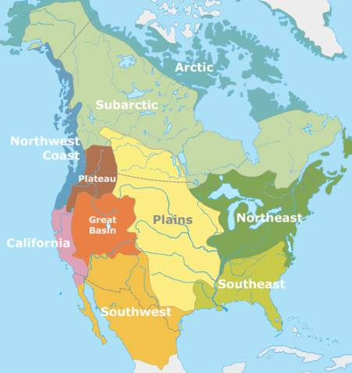
Day 2
Native American Regions Main Point Reading

1. What did many Native groups have in common?
Since 1492, European explorers and settlers have tended to ignore the vast diversity of the people who had previously lived here. It soon became common to lump all such groups under the term "Indian." In the modern American world, we still do. There are certain experiences common to the survivors of these tribes. They all have had their lands compromised in some way and suffered the horrors of reservation life.

2. How was religion usually passed down from generation to generation in many North American native societies?
There is no single “Native American Religion”, or church hierarchy. There is no central figure like Moses, Jesus, Muhammad or Buddha, nor is there a central holy book in Native American Religious tradition. It is an oral tradition that is passed down from generation to generation, based on certain guiding principles that are internalized from childhood and are an integrated part of each person’s life. Following the sacred way does not separate life into segments, it is seen as one.

3. Why have researchers created cultural group regions?
A culture area is a concept in cultural anthropology, in which a geographic region and time sequence (age area) is characterized by substantially uniform environment and culture.[1] The concept of culture areas was originated by museum curators and ethnologists during the late 1800s as means of arranging exhibits.

4. According to some scientists, how did Native Americans First cross into the
Americas?
Because the first humans and civilizations got their start in Africa and the Middle East, historians and anthropologists have had to figure out how Native Americans got to the Americas. In this lesson we look at the three prevailing theories of the earliest migration to the New World.
The most commonly held is the Bering Land Bridge Theory. This has been at the forefront for over 50 years. Basically, the idea is that during the last ice age, about 20,000 years ago (or a little less), lower water levels created a frozen bridge of land.

5. What do many Native American Religions have in common?
The sun dance is a religious ceremony practiced by a number of Native American and First Nations Peoples, primarily those of the Plains Nations. Each tribe that has some type of sun dance ceremony has their own distinct practices and ceremonial protocols. In most cases, the ceremony is held in a private, or even secret, location, and is not open to the public. Most details of the ceremony are kept secret out of great respect for, and the desire for protection of, the traditional ways. Many of the ceremonies have features in common, such as specific dances and songs passed down through many generations, the use of traditional drums, the sacred pipe, praying, fasting and, in some cases, the piercing of skin.

