Main Point Reading Day 6
The End of the War
- Who was the young French aristocrat who gave over $200,000 of his own money to the American cause?
George Washington met the nineteen-year-old Marquis de Lafayette on August 5, 1777, less than a week after the Continental Congress appointed the young Frenchman to be a volunteer Major General in the Continental Army. Lafayette served the cause without pay and actually paid the equivalent of more than $200,000 of his own money for the salaries and uniforms and other expenses for his staff, aides, and junior officers.
- What did Baron Friedrich Von Steuben do to help the Patriot troops?
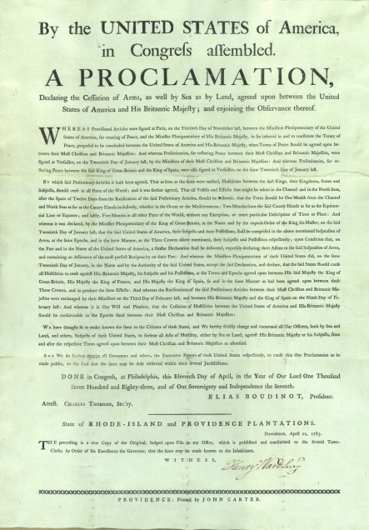
Von Steuben’s experiences as a General Staff member in the Prussian Army gave him a wealth of knowledge that heretofore was unheard of, even in the British and French armies of the period. His training would eventually bring to the American soldiers the technical knowledge necessary to create an ARMY.
- What was the last major battle that decided the fate of the war?
On this day in 1781, General George Washington, commanding a force of 17,000 French and Continental troops, begins the siege known as the Battle of Yorktown against British General Lord Charles Cornwallis and a contingent of 9,000 British troops at Yorktown, Virginia, in the most important battle of the Revolutionary War.
Although the war persisted on the high seas and in other theaters, the Patriot victory at Yorktown ended fighting in the American colonies. Peace negotiations began in 1782, and on September 3, 1783, the Treaty of Paris was signed, formally recognizing the United States as a free and independent nation after eight years of war.
- What was the treaty called that officially recognized the United States as an independent nation?
After the British defeat at Yorktown, peace talks in Paris began in April 1782 between Richard Oswarld representing Great Britain and the American Peace Commissioners Benjamin Franklin, John Jay, and John Adams. The American negotiators were joined by Henry Laurens two days before the preliminary articles of peace were signed on November 30, 1782. The Treaty of Paris, formally ending the war, was not signed until September 3, 1783. The Continental Congress, which was temporarily situated in Annapolis, Maryland, at the time, ratified the Treaty of Paris on January 14, 1784.

