Main Point Reading
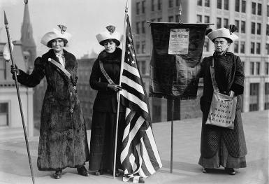
- A social reform movement is a kind of social movement that aims to make gradual change, or change in certain aspects of society, rather than rapid or fundamental changes. A reform movement is distinguished from more radical social movements such as revolutionary movements. Reformists' ideas are often grounded in liberalism, although they may be rooted in socialist (specifically, social democratic) or religious concepts.
- After the War of 1812, a costly stalemate, more and more Americans were holding debt, and the notion of imprisoning all these debtors seemed increasingly “feudal.” Moreover, America was seen as a country of immigrants, and many European immigrants had come here to escape debt. So, in 1833, Congress abolished the practice under federal law. Between 1821 and 1849, twelve states followed suit. Meanwhile, with the advent of bankruptcy law, individuals were given a way out of insurmountable debt, and creditors were made to share some of the risk inherent in a loan transaction. Legislation passed in 1841, 1867, and 1898 replacing a system that criminalized bankruptcy with one designed to resolve as much debt as the debtor could afford, while absolving the remainder.
- The experiences of mill women demonstrate that factory employment not only brought women’s work out of the home but also provided women a collective experience that supported their participation in the world of broader social reform. Lowell women became involved in anti-slavery, moral reform, peace, labor reform, prison reform, and women’s rights campaigns.
- These traditions also led mill women to become involved in a variety of other reform movements. Anti-slavery was strong in Lowell and mill women sent several petitions to Washington opposing slavery in the District of Columbia and opposing war with Mexico, which might contribute to an expansion of slavery into the Southwest. Woman reformers came to see opposition to black slavery and wage slavery as related causes. Some also participated in the women’s rights conventions that mushroomed after the first one was held in Seneca Falls, New York, in July 1848.
_____________________________________________________________________________________
- In the early 1800s, women were second-class citizens. Women were expected to restrict their sphere of interest to the home and the family. Women were not encouraged to obtain a real education or pursue a professional career. After marriage, women did not have the right to own their own property, keep their own wages, or sign a contract. In addition, all women were denied the right to vote. Only after decades of intense political activity did women eventually win the right to vote.

- Second Class Citizens
- Education
- Professional Career
- To get Married
- Voting
- Own Property
- Keep their income
- Sign a Contract

