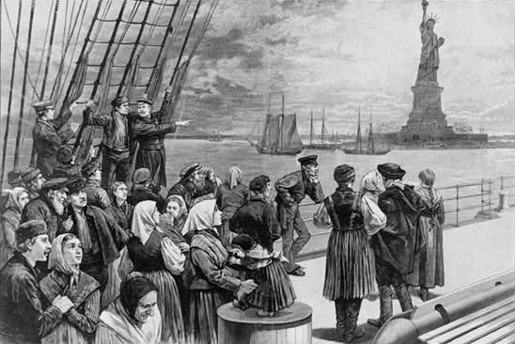

As the Lowell factories experienced booming growth, the conditions for the workers changed. The cities in which the textile factories operated became dirty, bleak industrial cities. Wage cuts and deteriorating working conditions became the norm. As the demand for cheap labor grew, immigrant child workers also became vulnerable to exploitation in the factories. Over half of the nation’s industrial workers in 1820 were immigrant children under the age of 10 who were both physically and mentally abused. Factory owners increasingly turned to Irish and German immigrants to operate their machines.
Enormous gains in industrial productivity, accompanied by institutional change and much lower transportation costs, created national markets with goods and people moving in every direction. Perhaps the most consequential change of the American industrial revolution was the increasing urbanization (the process where an increasing percentage of a population moves from the farmland to the cities) of northern cities and the shift of labor from farms to factories and offices. In 1880, workers in agriculture outnumbered industrial workers three to one, but by 1920, the numbers were approximately equal. Employment in the manufacturing sector expanded four-fold from 2.5 to 10 million workers from 1880 to 1920.
Working in the factories of the Industrial Revolution was hazardous. The factory workers faced safety hazards, health hazards, and cruel treatment. Factory machines were the latest technology, and factory owners were anxious to get their machines up and running. Safety was not a major concern. Dangerous parts of machines were not screened off. Machines were not equipped with features to make them shut off in case of an accident. Machine operators in textile mills, many of them young women, often had to reach over and around operating machinery as they did their job. Children hired as scavengers had to crawl under the machines to retrieve loose bits of cotton. Slightly older children hired as piecers had to step up onto the machines to tie loose threads back together. Injuries to these workers were frequent. In mill towns, many workers could be seen who had lost an arm or a leg to the machinery. Workers in the factories developed medical problems, too. The pollution and dust that were constantly in the air led to the illness known as mill fever. It was a dreaded disease, and it took many lives.
The growth of cities led to horrible living conditions. The wealthy fared far better than the industrial workers because they could afford to live in the suburbs on the outskirts of the city. However, for most of the factory workers, cities were dirty, crowded places where epidemics frequently broke out. Overcrowded row homes created to house the workers and their families contributed to these conditions. Government reports of the time indicated people sleeping as many as six to one bed. The sanitary conditions in early industrial cities were filthy as well. Since the municipal governments did not concern themselves with cleanliness at the time, the cities did not have proper waste disposal systems, and people threw trash and sewage directly into the streets. The burning coal of the industrial factories coated cities in a layer of grime and polluted the air, and water supplies were polluted by waste.

