The geography of the north and the south set up two very distinctly different societies which was a major factor that led to the Civil War.
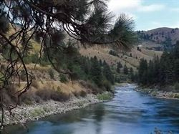
South
Although the south is somewhat like the north, it has many different features. For example, in January, the south has mild days and cool nights. The geography is very different there. In the south they have mountains, sub-tropical forests, and great farming lands. They also have many rainfalls, and the rivers are slow and easy to navigate, and therefore it was a good idea to establish the towns by the river, so they can transport goods. Because of the climate and long growing season, the economy of the south was agriculturally based which required slave labor. The south had short winters and long summers.
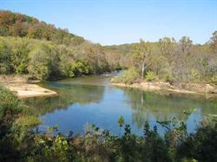
North
The north had vast forests and the land was certainly not as productive for farming as the south. The winters were long, cold and snowy. The north had fast rivers which made it difficult to navigate. The rivers were also very rocky. Because of the rough farming situations, the north focused on factories instead. They made numerous manufacturing products, and they also had a strong economy mining. Shipping was of larger part of their economic structure which led to a very diverse economy. They did all of this without slave labor. They had immigrants to assist in the labor. It allowed for great job opportunities in the north.

