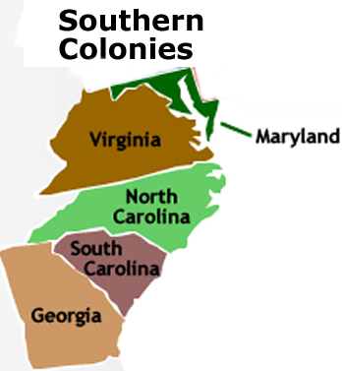
The Southern Colonies
Virginia was the first successful southern colony. While Puritan zeal was fueling New England's mercantile development, and Penn's Quaker experiment was turning the middle colonies into America's bread basket, the South was turning to cash crops. Geography and motive rendered the development of these colonies distinct from those that lay to the North.
Immediately to Virginia's north was Maryland. Begun as a Catholic experiment, the colony's economy would soon come to mirror that of Virginia, as tobacco became the most important crop. To the south lay the Carolinas, created after the English Civil War had been concluded. In the Deep South was Georgia, the last of the original thirteen colonies. Challenges from Spain and France led the king to desire a buffer zone between the cash crops of the Carolinas and foreign enemies. Georgia, a colony of debtors, would fulfill that need.
English American Southerners would not enjoy the generally good health of their New England counterparts. Outbreaks of malaria and yellow fever kept life expectancies lower. Since the northern colonies attracted religious dissenters, they tended to migrate in families. Such family connections were less prevalent in the South.
The economy of growing cash crops would require a labor force that would be unknown north of Maryland. Slaves and indentured servants, although present in the North, were much more important to the South. They were the backbone of the Southern economy.
Settlers in the Southern colonies came to America to seek economic prosperity they could not find in Old England. The English countryside provided a grand existence of stately manors and high living. But rural England was full, and by law those great estates could only be passed on to the eldest son. America provided more space to realize a lifestyle the new arrivals could never dream to achieve in their native land.

