Main Point Reading
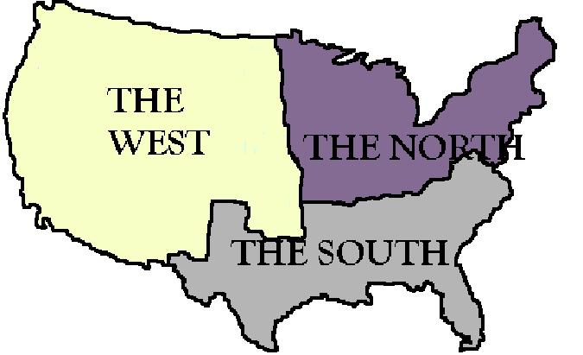
Slavery and Sectionalism

In national politics, sectionalism is loyalty to the interests of one's own region or section of the country, rather than to the country as a whole. It is often a precursor to separatism.
Each section of the country considered their region to be more important than the rest of the country. By 1820, three issues were dividing the nation. The first issue was the use of tariffs. The north wanted high tariffs. Tariffs made products from Europe (especially Great Britain) cost more and gave revenue to the federal government. Similar products made in the north would be sold easier when the competition was expensive. On the other hand, the south did not like tariffs at all. The south traded much of their cotton to Great Britain. In return, the south would receive British goods. But British goods would cost more with high tariffs added to them. This made the value of their cotton as a trading item worth less than before.
A second issue was the issue of transportation. The people in the west wanted to have better transportation systems so that they could be better connected to the rest of the country. This would provide a better means to sell and receive products. People in the north wanted better transportation systems too because they had the majority of the factories and it would get their products to market quicker. The people of the south didn't want to spend money on new roads or canals. They already had rivers that were suitable for their transportation needs.
A third issue was slavery. The slave trade with Africa ended in 1808. But slaves continued to be bought and sold in America. As the country grew westward, the people in the south wanted slavery to grow westward. The people in the north did not want slavery to grow in new territories.
Despite growing nationalism, the North and the South developed two distinctly different identities. While the North was rapidly modernizing itself, the South remained almost medieval, with life revolving around the plantation much as life revolved around the manor during the Middle Ages. Northerners were more revolutionary and cosmopolitan, while Southerners clung to tradition. This divide is still evident today. The North is comprised predominantly of "Blue states" (meaning that they are on the left side of the political spectrum); they embrace social change and new technology. The South, however, is comprised predominantly of "Red states" (meaning that they are on the right side of the political spectrum); they embrace traditional and strong moral values. The fact that these differences still exist today is evidence that history repeats itself...or perhaps never changes to begin with

