Day 4
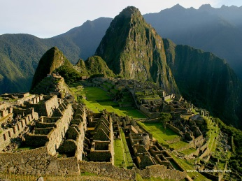
Central and South American Empires Main Point Reading
- What ancient empire stretched down along the Andes Mountains in South America?
Machu Picchu is a 15th-century Inca site located on a ridge between the Huayna Picchu and Machu Picchu mountains in Peru. It sits 7,970 feet (2,430 meters) above sea level on the eastern slope of the Andes and overlooks the Urubamba River hundreds of feet below.
- What was the name of the great Aztec city that was built on an island in the middle of a lake?
In his chronicle of the Spanish Conquest, the soldier Bernal Díaz marveled at the invaders' first glimpse of Tenochtitlán, the Aztec capital set on an island in a vast lake. The city and lakeside towns, he recalled, "rising from the water, all made of stone, seemed like an enchanted vision."
- How did other Native American groups who had been conquered by the Aztecs feel about the Aztec Empire and why?
The Aztecs were an extremely war-like civilization that were constantly attacking and subjugating their neighbors. Interestingly, though, their style of warfare was quite different from what we are familiar with from western European history.
For the Aztecs it was all about taking prisoners. The more prisoners you could bring home to sacrifice to the gods, the higher your standing. Thus, weaponry, tactics, and military strategy were all geared around maximizing capture of the enemy rather than defeating them in detail. They didn't really care about securing administrative control over their conquests quite the way the Europeans did, and often allowed the conquered to continue under their existing leadership, so long as they continued to send tribute.
- What nation lived in what is now Mexico and Central America from 250 AD to 900 AD and built impressive cities, but then mysteriously disappeared?
The El Tajin Period: 250-900 CE – This period is also known as the Classic Period in Mesoamerican and Mayan history. The name `El Tajin’ refers to the great city complex on the Gulf of Mexico which has been recognized as one of the most important sites in Mesoamerica. During this time the great urban centers rose across the land and the Maya numbered in the millions. The very important ball game which came to be known as Poc-a-Toc was developed and more ball courts have been found in and around the city of El Tajin than anywhere else in the region. Who, precisely, the people were who inhabited El Tajin remains unknown as there were over fifty different ethnic groups represented in the city and dominance has been ascribed to both the Maya and the Totonac.
- In 1400 AD, what empire was likely the largest in the world?
The Inca civilization flourished in ancient Peru between c. 1400 and 1533 CE, and their empire eventually extended across western South America from Quito in the north to Santiago in the south, making it the largest empire ever seen in the Americas and the largest in the world at that time.

