Day 2 – Main Point Reading
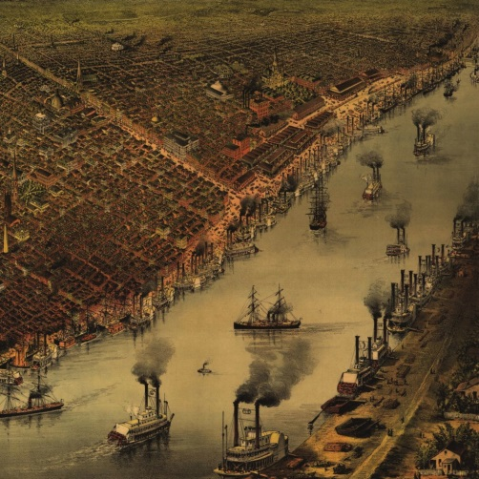
Rivers

Throughout America’s history, rivers have been incredibly important to the individuals living here. Whether it was the Native Americans, the early colonists, the explorers who traveled to the Pacific coast or us today, everyone in the United States is reliant on rivers. Rivers have been important for transportation, exploration, commerce, and water supply for centuries.
From its source, a river flows downhill as a small stream. Precipitation and groundwater add to the river’s flow. It is also fed by other streams, called tributaries. Many of these tributaries make up our most important river systems in the United States. The Mississippi, Missouri River systems are the fourth largest river system in the world. It serves as a highway system for transportation, industry, and recreation as the most important inland waterway in North America. The Missouri serves as the largest tributary to the Mississippi river. The Mississippi river travels downstream to the southern part of the United States until it hits the mouth of river at the Gulf of Mexico. The Mouth of the river is the location at the end of a river that empties into an ocean or sea.

