Main Point Reading Day 5
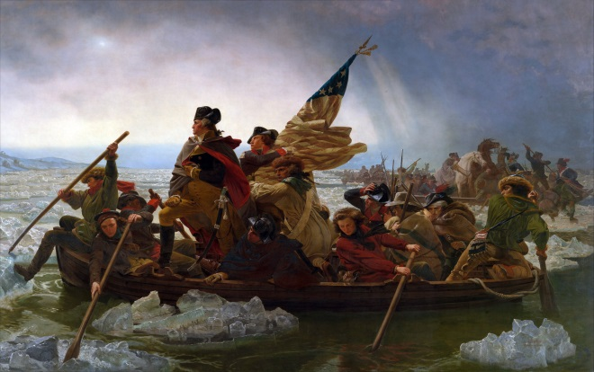
Revolutionary War Battles
- What was the first battle of the Revolution?
The Battles of Lexington and Concord, fought on April 19, 1775, kicked off the American Revolutionary War (1775-83). Tensions had been building for many years between residents of the 13 American colonies and the British authorities, particularly in Massachusetts. On the night of April 18, 1775, hundreds of British troops marched from Boston to nearby Concord in order to seize an arms cache. Paul Revere and other riders sounded the alarm, and colonial militiamen began mobilizing to intercept the Redcoat column. A confrontation on the Lexington town green started off the fighting, and soon the British were hastily retreating under intense fire.
- Who were the Hessians?
Hessians is the term given to the 18th-century German auxiliaries contracted for military service by the British government, who found it easier to borrow money to pay for their service than to recruit its own soldiers. They took their name from the German state of Hesse. The British used the Hessians in combat roles in several conflicts, including in the Irish Rebellion of 1798, but they are most widely associated with combat operations in the American Revolutionary War (1775-1783)
- What day did Washington and his troops cross the Delaware River?
During the American Revolution, Patriot General George Washington crosses the Delaware River with 5,400 troops, hoping to surprise a Hessian force celebrating Christmas at their winter quarters in Trenton, New Jersey. The unconventional attack came after several months of substantial defeats for Washington’s army that had resulted in the loss of New York City and other strategic points in the region.
At about 11 p.m. on Christmas, Washington’s army commenced its crossing of the half-frozen river at three locations. The 2,400 soldiers led by Washington successfully braved the icy and freezing river and reached the New Jersey side of the Delaware just before dawn.
- Why was the Battle of Saratoga significant?
The Battles of Saratoga were a series of military conflicts fought during September and October 1777 between the Kingdom of Great Britain and its thirteen colonies in North America during the American Revolutionary War (1775-1783). The significance of the conflict was that it proved to be the turning point of Revolutionary war and convinced the French of American strength which persuaded the French to support the Americans with military aid. The combined French and American forces achieved their first victory at the Battle of Monmouth.

