Name: _________________________________________________
Ecosystems Worksheet
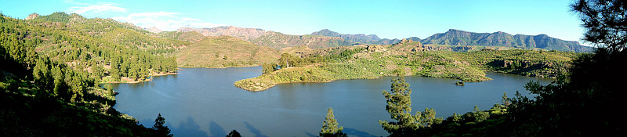
Directions: For each ecosystem, write the components that make it up in the space provided. Then, at the bottom of the sheet, fill in the commonalities between the 4 ecosystems.
Forest Ecosystem

Components:

Tundra Ecosystem

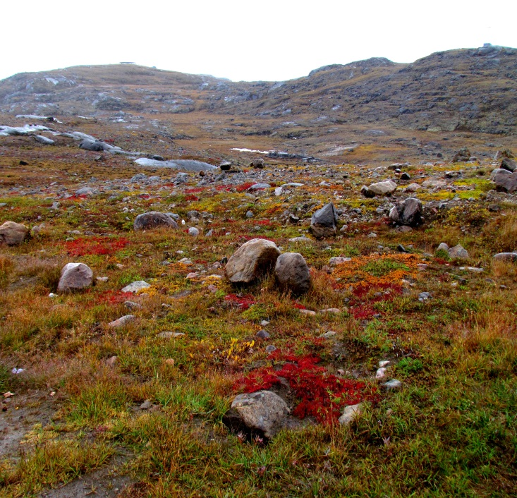
Components:

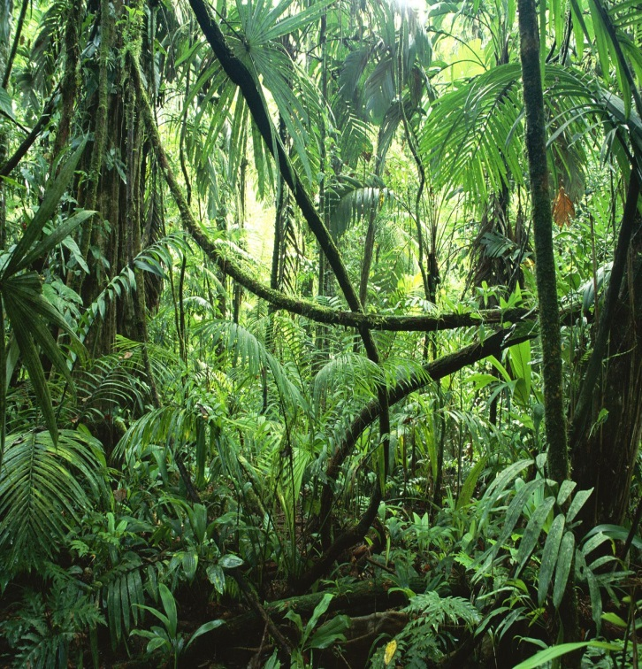
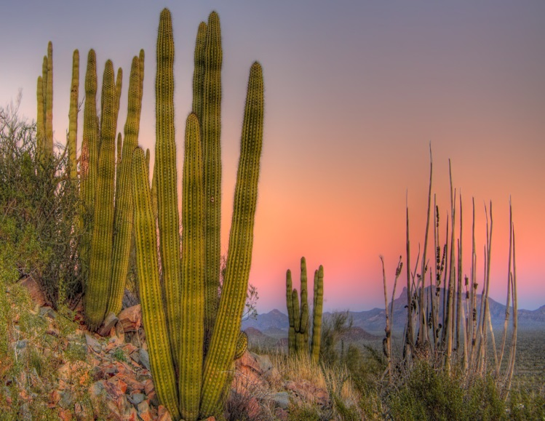
Rain Forest Ecosystem
Components:
Components:
Similarities between all 4 ecosystems:
Desert Ecosystem

