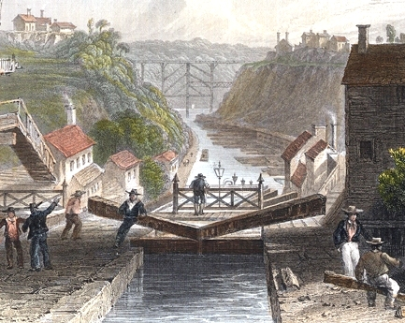
Main Point Reading
Industry Comes to America

- New York legislators became interested in the possibility of building a canal across New York in the first decade of the 19th century. Shipping goods west from Albany was a costly and tedious affair; there was no railroad yet, and to cover the distance from Buffalo to New York City by stagecoach took two weeks. By 1817, the Erie Canal was constructed at the expenditure of $7 million. The canal would be 363 miles long, 40 feet wide, and four feet deep.
The effect of the canal was immediate and dramatic. Settlers poured into western New York, Ohio, Michigan, Illinois, and Wisconsin. Goods were transported at one-tenth the previous fee in less than half the previous time.
- Morse code is a method of transmitting text information as a series of on-off tones, lights, or clicks that can be directly understood by a skilled listener or observer without special equipment. The International Morse Code uses a small set of punctuation and procedural signals as standardized sequences of short and long signals called "dots" and "dashes”, or "dits" and "dahs", as in amateur radio practice.
- Francis Cabot Lowell invented the first factory system "where people and machines were all under one roof." A series of mills and factories were built along the Merrimack River by the Boston Manufacturing Company, an organization founded in years prior by the man for whom the resulting city was named. Construction began in 1821, and the mills were at their peak roughly twenty years later. For the first time in the United States these mills combined the textile processes of spinning and weaving under one roof, essentially eliminating the "putting-out system" in favor of mass production of high-quality cloth. The workforce at these factories was three-quarters women.
- In a country as large as the United States, it is easy to see why fast transportation became increasingly important. In the beginning, Americans relied on horses, wagons, and coaches. As late as 1830, the trip from Boston to New York took two days on a fast stagecoach.
The expanding country desperately needed a quicker and more efficient form of transportation. In the 1820s George Stephenson had introduced the first successful steam locomotive in England. By 1829, several of his locomotives had been shipped to the United States. The next year the first U.S. railroad began to operate in Charleston, South Carolina. Railroads quickly filled a vital need for travel across the country.
- During the Industrial Revolution of the 19th century, machines took over most of the manufacturing work from men, and factories replaced craftsmen’s workshops. The event that laid the groundwork for this monumental change was the introduction of interchangeable parts, or pre-manufactured parts that were for all practical purposes identical, into the firearms industry. Interchangeable parts, popularized in America when Eli Whitney used them to assemble muskets in the first years of the 19th century, allowed relatively unskilled workers to produce large numbers of weapons quickly and at lower cost, and made repair and replacement of parts infinitely easier.

