Main Point Reading
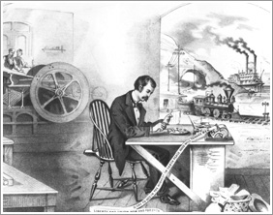
The Industrial Revolution

The factory system is a method of manufacturing using machinery and division of labor. Because of the high capital cost of machinery and factory buildings, factories are typically owned by capitalists who employ the operative labor. Use of machinery with the division of labor reduced the required skill level of workers and also increased the output per worker.
The factory first adopted in England at the beginning of the Industrial Revolution in the late 18th century and later spread abroad. It replaced the artisan system or the workshop system.
Prior to the Industrial Revolution, which began in Britain in the late 1700s, manufacturing was often done in people's homes, using hand tools or basic machines. Industrialization marked a shift to powered, special-purpose machinery, factories and mass production.
The Industrial Revolution made work become more regimented and less skilled. Instead of working for yourself, at your own pace, you had to work for a boss and work when and how hard that boss told you to. This made workers feel much less independent than they once had. So, in general, the Industrial Revolution made the workforce a much more impersonal and took away the independence of the workers it employed.
The most important of the changes that brought about the Industrial Revolution were (1) the invention of machines to do the work of hand tools; (2) the use of steam, and later of other kinds of power, in place of the muscles of human beings and of animals; and (3) the adoption of the factory system.
- Now that you have gained a small understanding about the industrial revolution, in your own words, give me a short definition in a complete sentence format of what the industrial revolution is to answer your final Main Point Reading question.

